Delivery Personalized Movie Recommendation with an AI-driven Matchmaking System

NAME : [PUGAZHARASU.S]

REGISTER NUMBER : [511923205038]

INSTITUTION : [BACHLER OF TECHNOLOGY] DEPARTMENT : [INFORMATIONTECHNOLOGY] DATE OF SUBMISSION DATE : [02-05-2025]

GITHUB REPOSITORY LINK: https://github.com/Pavithran055/project.git

# Problem Statement:

**Existing movie recommendation systems often rely on simplistic representations of movie metadata, failing to capture nuanced relationships between movies and user preferences. This limitation leads to inaccurate recommendations, a lack of contextual**

**understanding, and insufficient personalization, resulting in generic suggestions that don't account for individual users' viewing histories and ratings. To address these challenges, we aim to develop an AI-driven matchmaking system that effectively represents movie metadata to deliver highly personalized movie recommendations.**

**The current systems' inability to effectively utilize movie metadata, such as genres, directors, and plot summaries, results in a significant gap between user expectations and the recommendations provided. By leveraging advanced techniques in natural language processing and machine learning, our system will learn to represent movie metadata in a way that captures the complexities of user preferences, enabling more accurate and personalized recommendations that enhance the overall user experience**.

# Project Objectives:

**The objective of this project is to develop an AI-driven matchmaking system that effectivelyrepresents movie metadata to deliver highly personalized movie recommendations, improving the accuracy and relevance of suggestions, enhancing user experience, and leveraging advanced techniques in natural language processing and machine learning to capture complex relationships between movie metadata and user preferences.**

**achieving this objective, the system aims to provide users with a more engaging**

**and satisfying movie-watching experience, increasing user retention and overall platform value, while also enabling content providers to better understand and cater to their audience's preferences.**

# Flowchart of the project workflow:

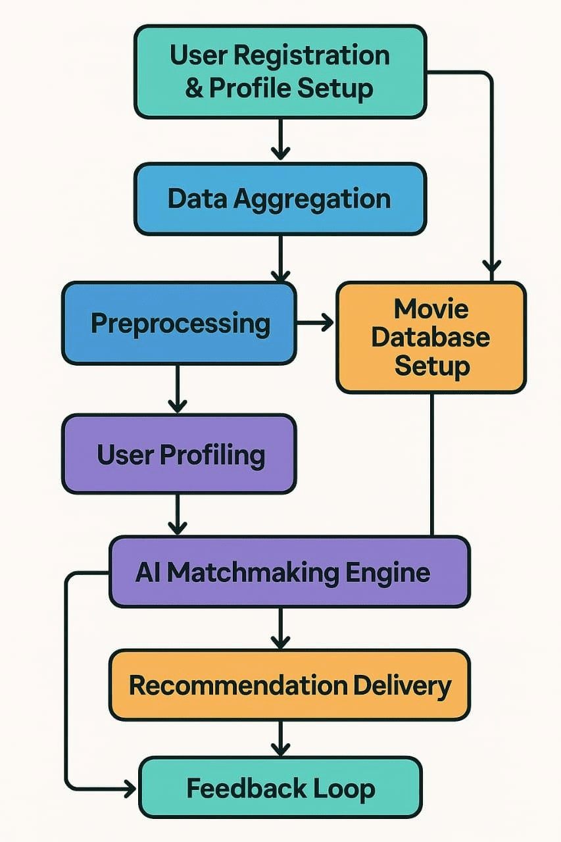

1. Data description:

Name: MovieLens 100k Dataset

Source: GroupLens Research

Type: Structured Data

Records: 100,000 ratings | 943 users | 1682 movies Static Dataset

Target Variable: User rating (explicit feedback)

# user profiling and data collection”

**Data profiling for delivery personalized movie recommendation with an AI-driven matchmaking system involves analyzing user behavior, preferences, and ratings to create detailed profiles. This process helps identify patterns and trends in user data, enabling the system to make informed recommendations that cater to individual tastes.**

**Data collection is a critical component of this system, involving the gathering of**

**user ratings, movie metadata, and other relevant information. This data can be sourced from various channels, including user feedback, movie databases, and online platforms, and is used to train and refine the AI-driven matchmaking algorithm to provide accurate and personalized movie recommendations**.

# reccomendation algorithms and machine learing models:

**The delivery personalized movie recommendation system leverages machine learning models such as collaborative filtering, content-based filtering, and hybrid**

**approaches to learn user preferences and movie characteristics. These models enable the system to identify complex patterns and relationships in user behavior and movie metadata.**

**The system employs recommendation algorithms like K-Nearest Neighbors (KNN), Matrix Factorization (MF), and Deep Learning-based models to generate personalized movie recommendations. These algorithms analyze user profiles, movie attributes, and rating patterns to predict user preferences and provide accurate recommendations that enhance the overall user experience.**

# Aatural language processing in analyzing reviews and descriptions:

**Natural Language Processing (NLP) plays a crucial role in analyzing movie reviews and descriptions to extract valuable insights and sentiment. The system utilizes NLP techniques such as sentiment analysis, entity recognition, and topic modeling to understand user opinions and preferences, enabling more accurate and personalized movie recommendations.**

**By analyzing textual data from reviews and descriptions, the system can identify key themes, emotions, and opinions associated with movies, allowing for a deeper**

**understanding of user preferences. This information is then integrated with other data sources to generate highly personalized recommendations that cater to individual tastes and interests**

# Evaluation metrices and performance optimization:

**The performance of the AI-driven matchmaking system is evaluated using various metrics, including precision, recall, F1-score, mean average precision (MAP), and normalized discounted cumulative gain (NDCG). These metrics provide insights into the system's ability to accurately recommend movies that align with user preferences.**

**To optimize the system's performance, techniques such as hyperparameter tuning, cross-validation, and model ensemble are employed. The system is continuously monitored and updated to ensure that it adapts to changing user behavior and preferences, providing the most accurate and personalized movie recommendations possible.**

# Ethical considerations and data privacy in AI recommendations:

**The use of AI-driven matchmaking systems for personalized movie**

**recommendations raises important ethical considerations, including data privacy, bias, and transparency. To address these concerns, the system is designed with robust data protection measures, ensuring that user data is securely stored and processed in compliance with relevant regulations.**

**The system also incorporates mechanisms to prevent bias and ensure fairness in recommendations, such as regular audits and testing for disparate impact. Furthermore, users are provided with clear information about data collection and usage, and are given control over their data preferences, enabling them to make informed decisions about their participation in the system.**

# Fundamentals of Recommendation Systems

* + **Types of Recommendation Systems:**
* **Collaborative Filtering:**
* **Utilizes user behavior and preferences to suggest content.**
* **Content-Based Filtering:**
* **Relies on item attributes to recommend similar content.**
* **Hybrid Models:**
* **Combines both collaborative and content-based approaches for improved accuracy**

# AI Techniques in Movie Recommendations

* + **Machine Learning Algorithms:**
* **Implementation of algorithms like Singular Value Decomposition (SVD) for collaborative filtering.**
  + **Deep Learning Approaches:**
* **Use of Neural Networks to capture complex user-item interactions.**
  + **Natural Language Processing (NLP):**
* **Analyzing user reviews and movie metadata to extract meaningful patterns.**

# The Architecture of an AI-Driven Matchmaking

**An AI-driven matchmaking system for movie recommendations is built on a modular architecture that includes components such as data ingestion, feature extraction, model training, and real-time recommendation. The process begins with collecting raw user data and movie metadata, which are then preprocessed to extract meaningful features. Natural Language Processing (NLP) techniques are applied to analyze movie descriptions, reviews, and subtitles,**

**enabling the system to understand content at a semantic level. These insights are fed into machine learning models that learn user preferences over time.**

**The matchmaking engine operates at the core of the architecture. It continuously matches**

**users with the most suitable content using deep learning and similarity-based techniques. These models are trained to identify latent factors that influence a user’s preferences, allowing the system to make accurate predictions. The system is designed to operate in real time, adjusting recommendations based on new interactions. A feedback loop further enhances accuracy, as it updates the model with new data to reflect changes in user behavior.**

# Algorithms Behind Movie Recommendations:

**The backbone of AI-based movie recommendation systems lies in the algorithms used to**

**infer preferences. Matrix factorization is a popular method that reduces the user-item interaction matrix into latent features, enabling efficient similarity matching. Neural collaborative filtering takes this further by incorporating neural networks to capture nonlinear relationships between users and items. Autoencoders are also employed to manage sparse data, helping reconstruct missing interactions and improve predictions.**

**Advanced algorithms such as reinforcement learning are gaining traction for their ability to adapt recommendations dynamically. In this approach, the system is treated like an agent that learns optimal recommendations through reward-based feedback. Hybrid models that combine collaborative and content-based filtering techniques are also commonly used to leverage the strengths of both approaches. By continuously refining the algorithmic strategies, these systems can achieve a balance between accuracy, diversity, and novelty in recommendations**.

# Personalization Techniques and User Data Handling:

**Personalization techniques rely heavily on capturing and analyzing user behavior across**

**multiple dimensions. This includes clickstream data, session duration, skipped content, and device usage patterns. Psychographic and demographic information further enrich the user profile, allowing for a more nuanced recommendation strategy. Temporal factors are also considered — the recency of user interactions influences the weight given to specific behaviors. Together, these data points create a dynamic and comprehensive profile for each user.**

**Handling user data responsibly is a major consideration in AI-driven personalization.**

**Ethical data collection practices must be upheld, ensuring transparency and user consent. Privacy- preserving technologies such as differential privacy and federated learning are being explored to enable data utilization without compromising security. Moreover, personalization systems must address challenges like the cold start problem, which occurs when new users or items lack sufficient data. Techniques such as popularity-based priors and transfer learning help mitigate these issues**

# Applications, Challenges & Future Directions:

**AI-driven movie recommendation systems have found successful applications in platforms like Netflix, Amazon Prime, and Disney+. These platforms use complex algorithms to provide viewers with curated content that keeps them engaged. However, the implementation is not**

**without challenges. Data sparsity, user fatigue from repetitive recommendations, and algorithmic bias can hinder the effectiveness of these systems. Developers must constantly refine models to address these limitations while ensuring fairness and inclusivity in recommendations.**

**Looking forward, the future of personalized movie recommendations is incredibly**

**promising. Emotion-aware systems that adapt to a viewer's mood, integration with augmented and virtual reality for immersive experiences, and the use of generative AI for dynamic content suggestions are some emerging trends. Additionally, social integration — leveraging data from friends and communities — could further enrich recommendations. As technology evolves, these systems will continue to redefine the way audiences interact with content, making movie discovery more intuitive and enjoyable.**

# System Architecture:

**The AI-driven matchmaking system consists of multiple components, including data ingestion, processing, and recommendation generation. These components work together seamlessly to provide personalized movie recommendations.**

* **Data ingestion: collecting user ratings, movie metadata, and other relevant data**
* **Data processing: cleaning, transforming, and storing data in a suitable format**
* **Recommendation generation: using algorithms to generate personalized recommendations**
* **Scalability: designing the system to handle large volumes of data and user traffic**

**The system's architecture is designed to be scalable and flexible, allowing for easy integration with various data sources and recommendation algorithms.**

* **Microservices architecture: breaking down the system into smaller, independent services**
* **API-based integration: using APIs to integrate with other systems and services**
* **Cloud-based infrastructure: using cloud services to provide scalability and reliability**

# User Interface and Experience

**The user interface plays a crucial role in delivering personalized movie recommendations.**

**The system provides a user-friendly interface that allows users to easily interact with the system and receive recommendations.**

* **User profiling: collecting user data and preferences to create personalized profiles**
* **Recommendation presentation: presenting recommendations in a clear and engaging manner**
* **User feedback: allowing users to provide feedback and ratings on recommended movies**
* **Personalization: tailoring the user interface to individual user preferences**

**The system's user experience is designed to be intuitive and engaging, providing users with a personalized movie-watching experience that meets their individual preferences.**

* **Streamlined navigation: making it easy for users to find and watch recommended movies**

# Content Analysis and Feature Extraction:

**The system analyzes movie content and extracts relevant features, such as genre, director, and cast. These features are used to generate personalized recommendations.**

* **Natural Language Processing (NLP): analyzing text-based data such as movie reviews and descriptions**
* **Named Entity Recognition (NER): identifying and extracting specific entities such as actors and directors**

**The system's content analysis capabilities enable it to understand the nuances of movie content and provide recommendations that align with user preferences.**

* **Entity extraction: extracting relevant entities such as genres, directors, and actors**
* **Topic modeling: identifying underlying themes and topics in movie content**
* **Sentiment analysis: analyzing user sentiment and opinions on movies**

# Context-Aware Recommendations:

**The system provides context-aware recommendations that take into account user preferences, location, and time. This enables the system to provide recommendations that are relevant to the user's current context.**

* **Location-based recommendations: providing recommendations based on the user's location**
* **Time-based recommendations: providing recommendations based on the time of day or day of the week**
* **Event-based recommendations: providing recommendations based on specific events or holidays**

**The system's context-aware capabilities enable it to adapt to changing user behavior and preferences, providing recommendations that are always relevant and timely.**

* **User behavior analysis: analyzing user behavior and preferences to provide context-aware recommendations**
* **Contextual data integration: integrating contextual data such as weather, location, and time**
* **Real-time processing: processing contextual data in real-time to provide up-to-date recommendations**

# Scalability and Performance:

**The system is designed to be scalable and performant, handling large volumes of user data and movie metadata. This enables the system to provide fast and accurate recommendations.**

* **Distributed architecture: designing the system to distribute workload across multiple servers**
* **Load balancing: balancing workload across multiple servers to ensure high performance**
* **Caching: using caching mechanisms to improve system performance**

**The system's scalability and performance capabilities enable it to handle increasing user demand and provide a seamless user experience.**

* **Horizontal scaling: scaling the system horizontally to handle increasing user demand**

TEAM MEMBERS AND CONTRIBUTION:

MUKESH– PROBLEM STATEMENT AND PROJECT OBJECTIVES

PAVITHRAN– FLOWCHART OF THE PROJECT WORKFLOW, DATA DESCRIPTION, DATA PREPROSSING, EXPLORATORY DATA ANALYSIS

PUGAZHARASU – FEATURE ENGGINEERING AND MODEL BUILDING

SANTHOSH – VISUALIZATION OF RESULTS & MODEL INSIGHTS AND TOOLS & TECHNOLOGIES USED